Notes on CPIC development

Most recent updates:

1. Removed “phenotype” dictionary key. Only diplotype, allele1 and allele2 retained
2. Edited Input xml to reflect reduction in parameters passed. Deleted phenotype and adjusted number of parameters from 4 🡪 3.
3. Edited Build.py in MakeKO file to be compatible for python3.
4. Created CPIC_GPWizard(v1.1).py. This wizard has been updated to contain the latest updated skeleton code for the genotype to phenotype payload, as well as an updated inputxml.
5. Emailed James Hoffman about questions.
6. CPIC_GPWizard(v1.1).py modified to generate ark ID using file name
7. Comments explaining how to use the skeleton geno-pheno (payload code) results in an error when running. REMOVED for the Wizard.

Current work:

1. Working to create a KO for phenotype to recommendation
   1. Begin with easy model UGT1A1
   2. CYP2C19
   3. CYP2D6
2. Email: James Hoffman for table data (cc Allen in email)
3. Re-visited the Wizard. How can we customize this?
4. Testing KO
5. Testing: Have Tina follow READ_ME for CPIC_Wizard to see if it makes sense.
6. changes

Questions/Concerns:

1. Difference in formatting from the 2013 paper vs 2015 paper. Something to keep in mind as we create phenotype to recommendation KO because the header names are different. Need to set a standard.

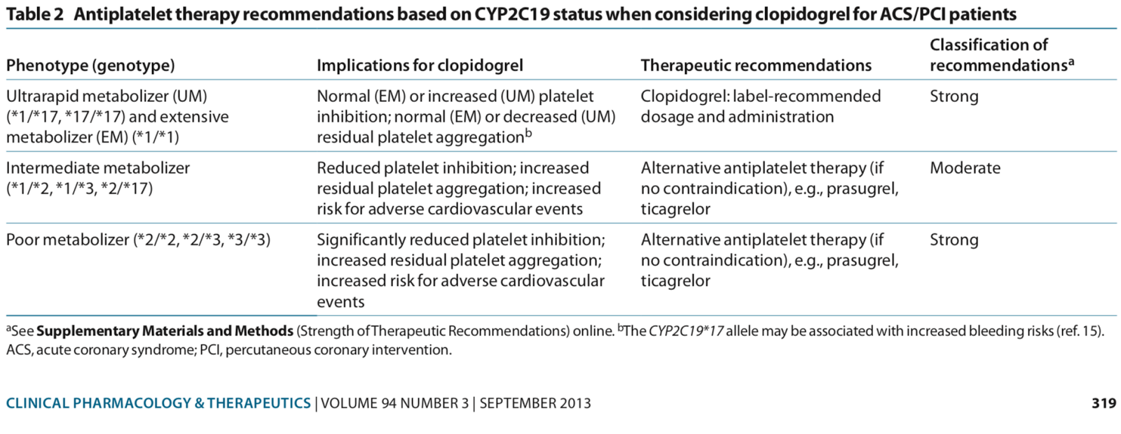

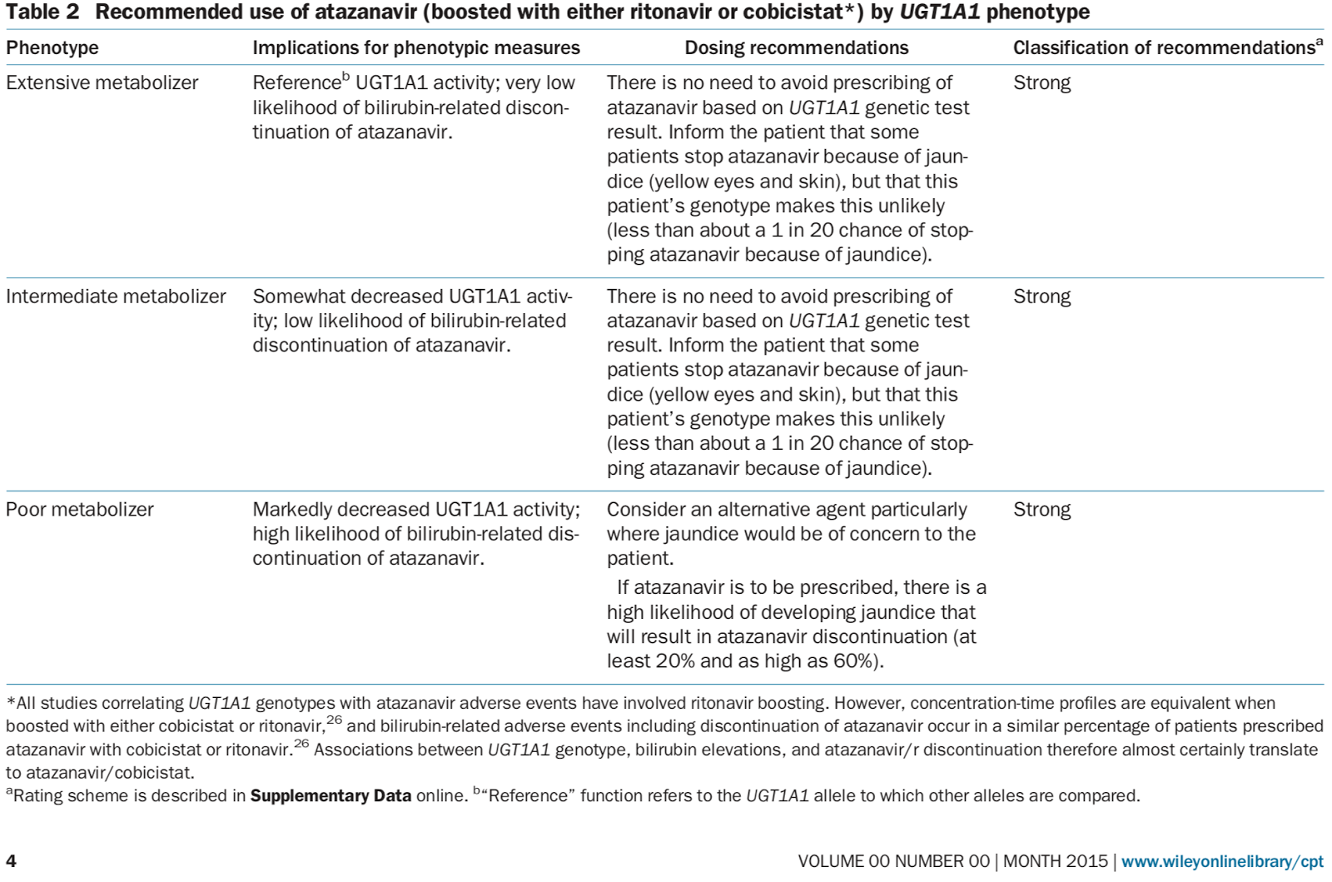

1. The CYP2C19 table has rapid metabolizer, intermediate metabolizer, likely intermediate metabolizer (treat as intermediate according to CPIC people), likely poor metabolizer, and poor metabolizer. The paper on CYP2C19 published in 2013 contains extensive metabolizer which does NOT exist in the table.